NIST SSDF Compliance for Log360
Strengthen cybersecurity and meet NIST SSDF compliance with Log360.
Region: USA | Type: Government/Public Sector, Industry Standard | Category: Compliance | Pricing: Free

Overview
The NIST SSDF compliance extension in Log360 helps organizations meet NIST SP 800-218 Secure Software Development Framework (SSDF) v1.1, the NIST framework referenced in US Executive Order 14028 mandating secure development practices for software producers serving federal agencies by providing centralized log management, development environment monitoring, and vulnerability tracking. The platform supports NIST SSDF requirements for secure development policy governance, environment protection, source code integrity, configuration security, vulnerability identification, remediation tracking, and root cause analysis.
For PO.1: Establish Secure Development Policies, Log360 monitors policy change events, GPO updates, user account management, and group administration activities to track policy compliance and governance. To address PO.3: Secure Development Environment, the platform monitors logon events, failed authentication, and SUDO commands on development servers to detect unauthorized access to build infrastructure. The extension also supports PS.1: Protect Source Code and Build Artifacts by providing capabilities that monitors file change events, registry modifications, USB storage activity, and cloud file uploads on development systems to detect code tampering or theft.

Key Features
- PS.3: Archive and Protect Software Releases: Log360 monitors cloud storage activities, backup operations, and file access events to track release archive integrity and detect unauthorized modifications.
- PW.6: Secure Software Configuration: Log360 monitors network device configuration changes, policy updates, registry modifications, and software update events to identify unauthorized configuration changes.
- RV.2: Assess and Remediate Vulnerabilities: Log360 monitors patch deployment events, software update activities, system configuration changes, and process execution logs to verify remediation progress.
- RV.3: Root Cause Analysis and Post-Incident Feedback: Log360 provides deep forensic visibility and event correlation across the development lifecycle, enabling security teams to identify the root causes of vulnerabilities and integrate those findings back into the secure build process.
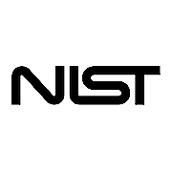
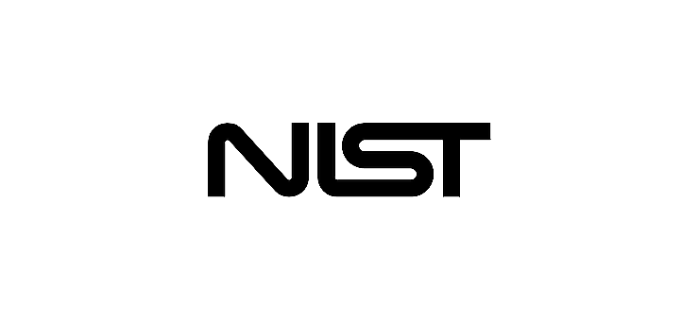
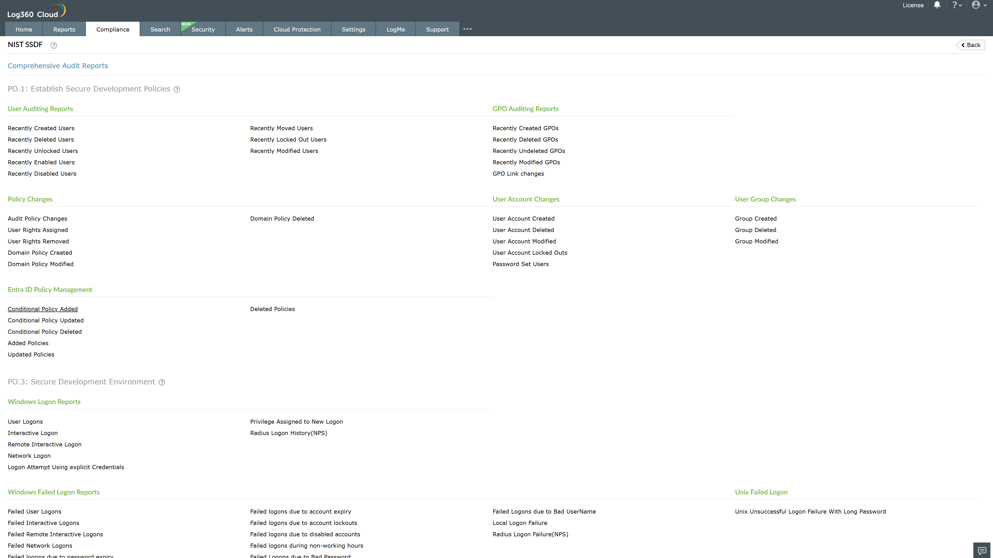
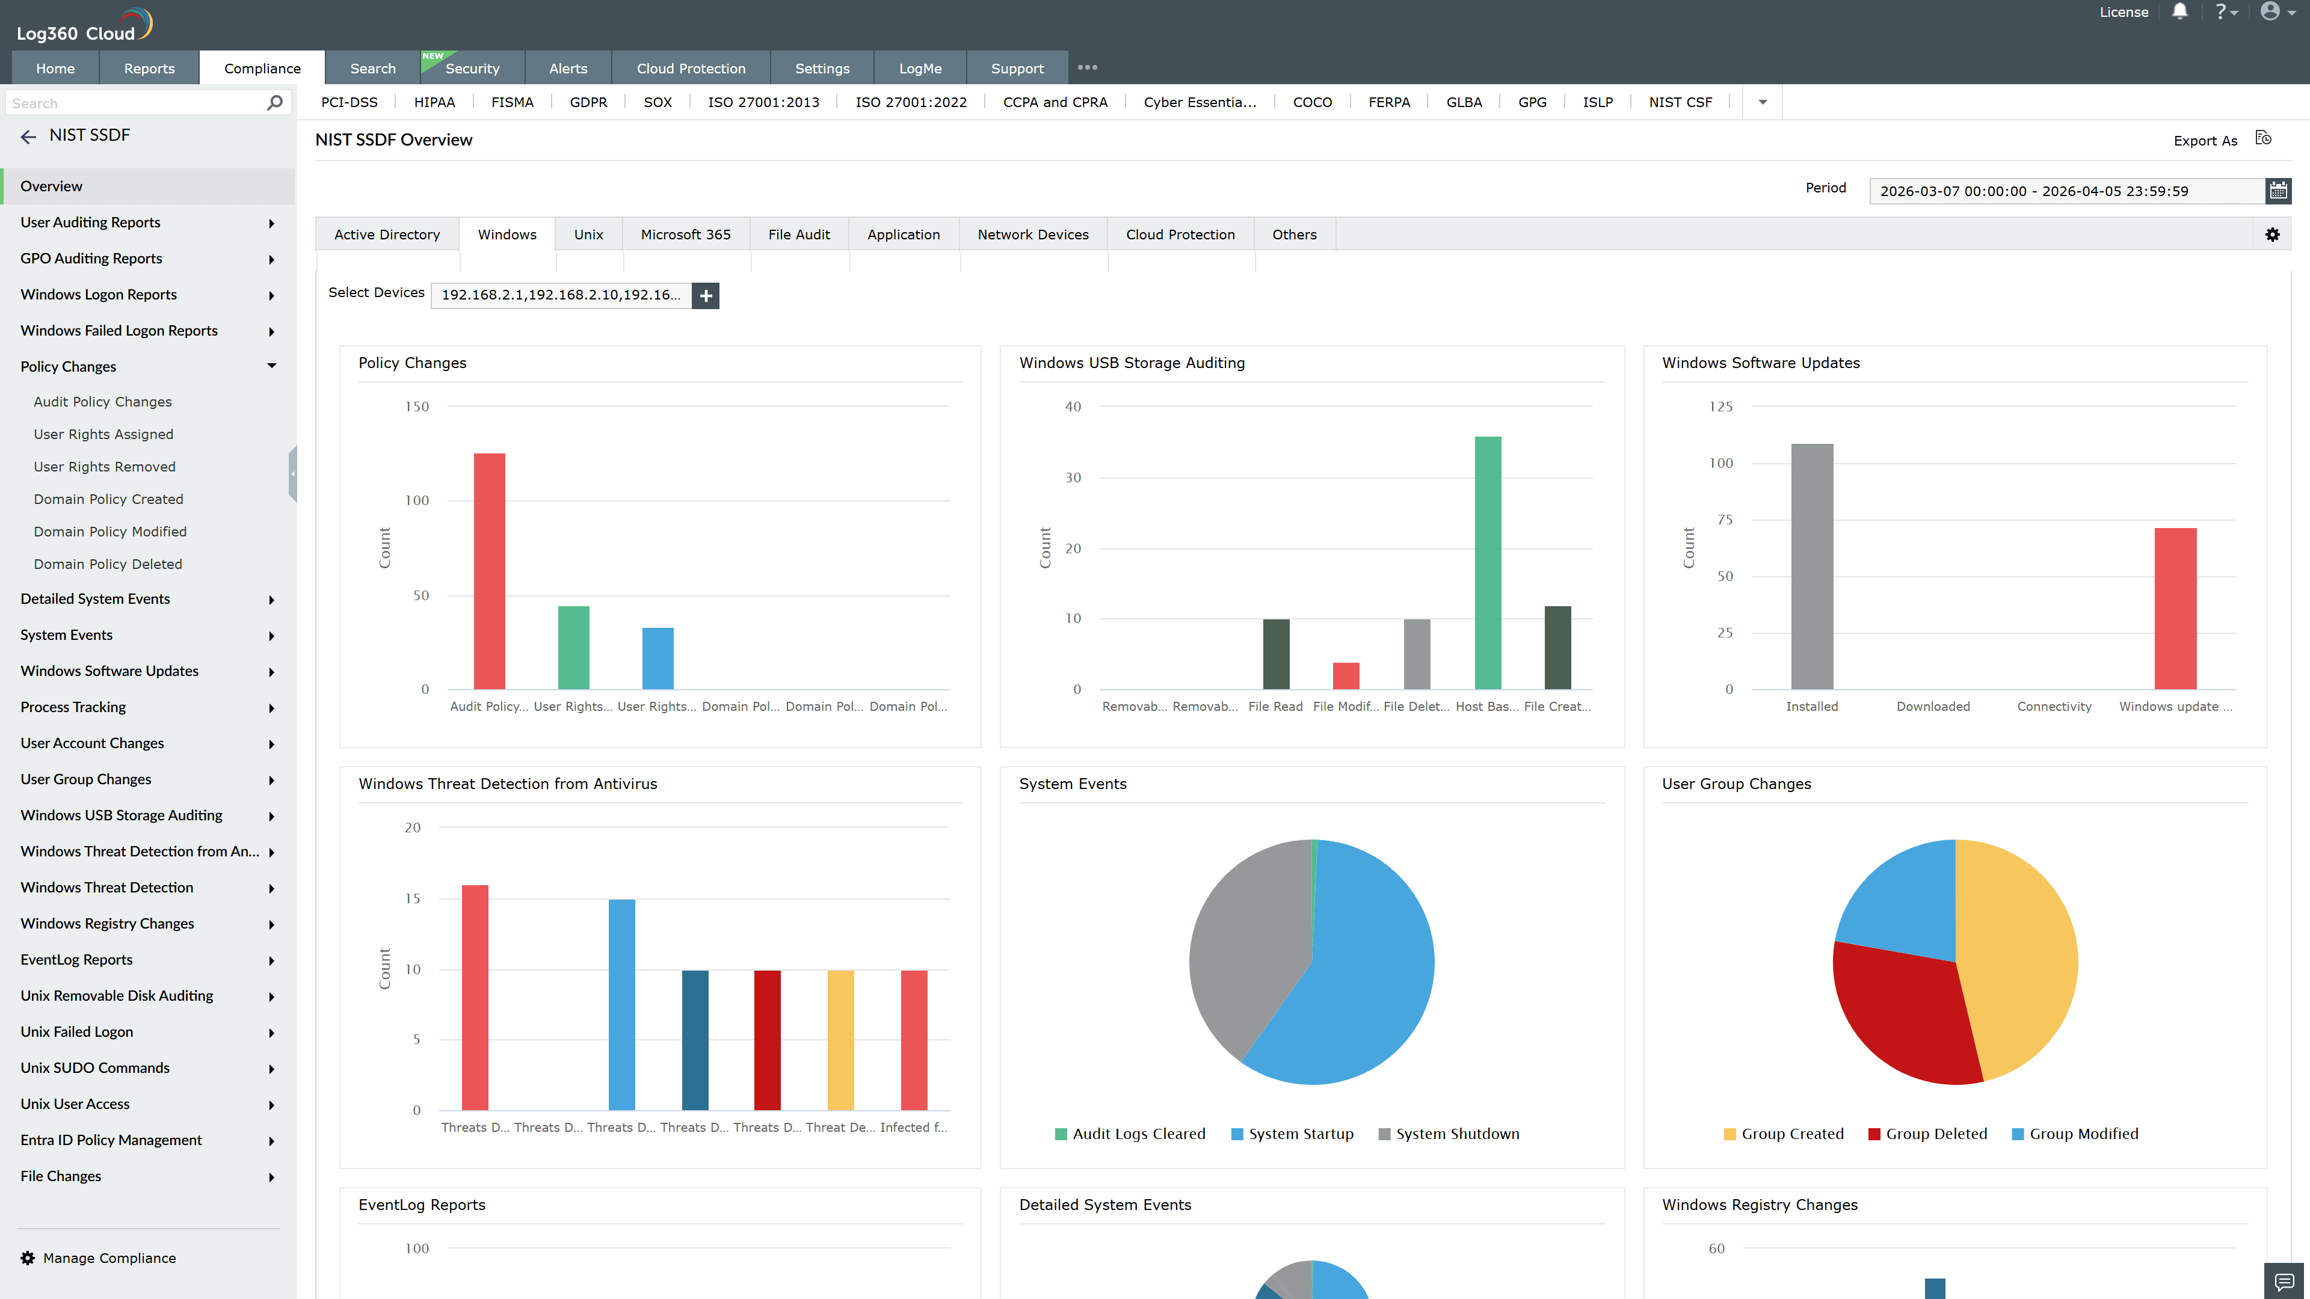
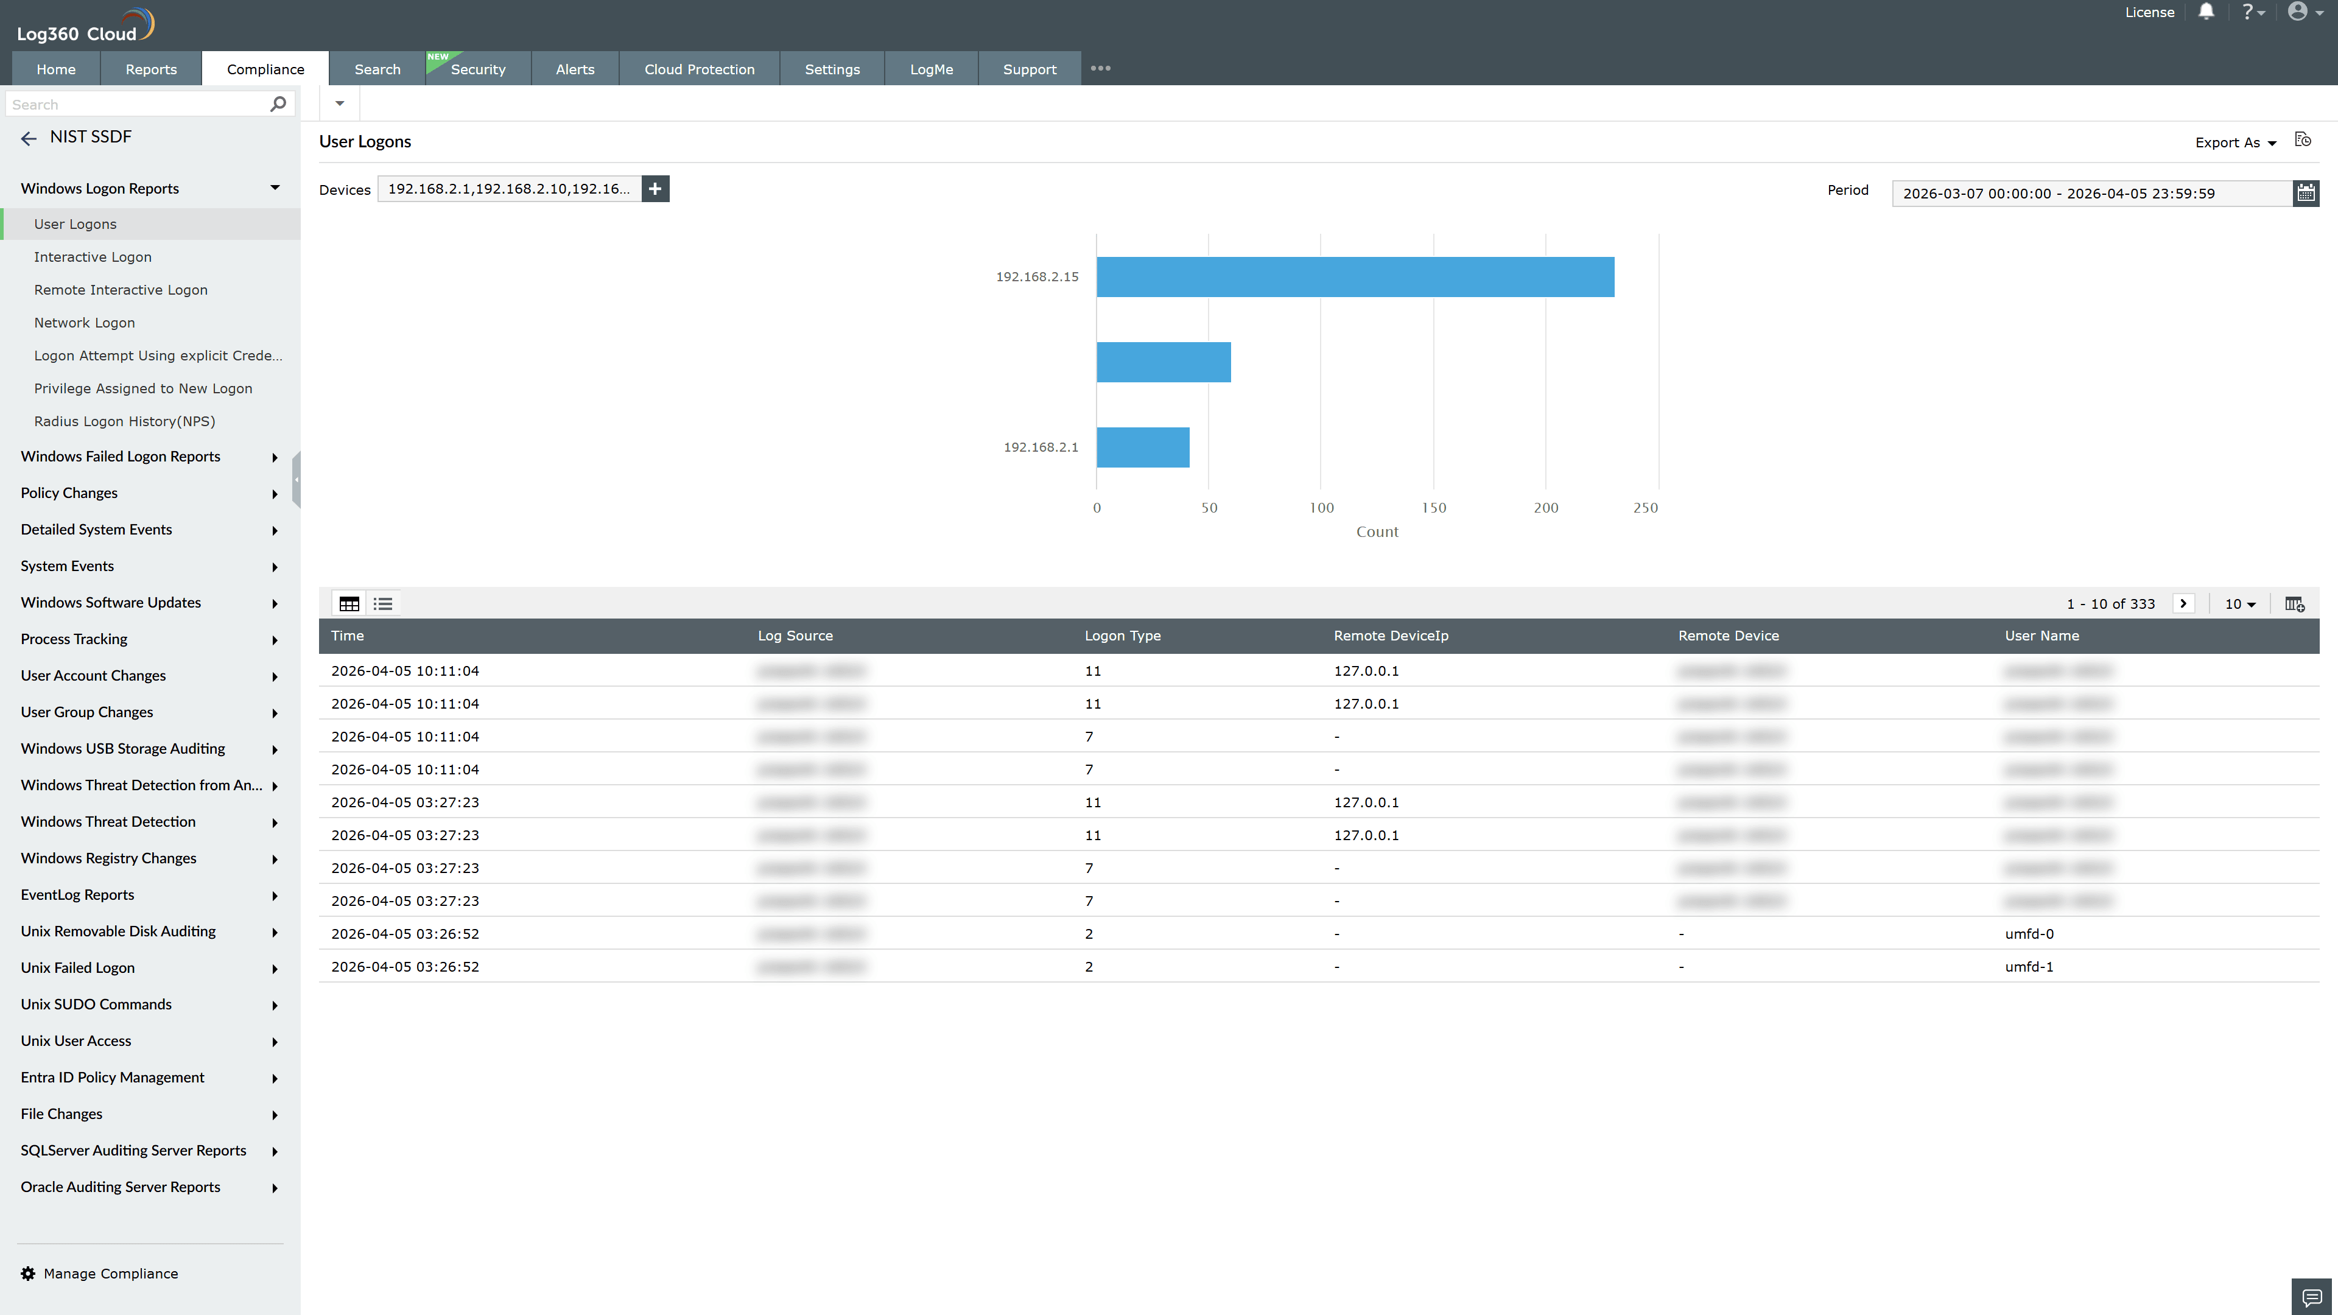
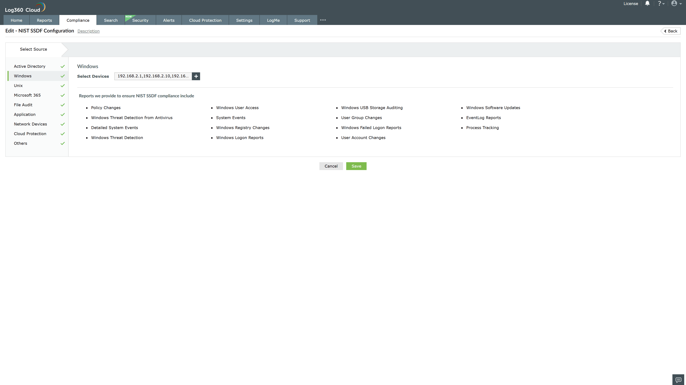
Valid Submission : Yes
Supported Editions : Free, Basic, Standard, Professional, MSSP
Help Document : https://www.manageengine.com/log-management/help/integrations/compliance-extensions.html
Help Video : Not provided
Tags : Log360, Compliance, Privacy monitoring, Data privacy, Regulatory compliance
Supported DCs : US, IN, JP, CA, AU, UK and EU
Privacy Policy:
Terms of Service:
Release Notes:
Predefined reports for the NIST SSDF.

